Microcontroller Training Lesson 1 – Configuring the IDE
by Bryan A. CrazyUncleBurton Thompson
Last Updated 3/8/2026

Overview
Our goal is to create a unified development environment which supports thousands of microcontrollers and development boards. VS Code and all the extensions and support apps mentioned in this document are all free downloads.

Theory
Millions of hours are wasted every year installing and configuring unique IDEs and compilers and libraries every time the developer wants to try a new microcontroller platform.
Our solution is Microsoft VS Code, a free and well-supported Integrated Development Environment in the embedded development world.
Git / CVS software version control is necessary for software developers in 2026, but it’s complicated and so we choose to present that lesson after we learn some fundamentals.

Prerequisites
Admin rights on the computer are needed to install some applications including Visual Studio. Extensions and Projects are stored in the user’s profile, so admin is not necessary for extensions.

Objectives
- Install Microsoft Visual Studio Code.
- Install required extensions within VS Code.
- Clone the Microcontroller Training repository to the local hard drive.
- Familiarize yourself with the repository

Setting Up a New Computer

Install VS Code
Note: This section only needs to be done once for each computer.
- Browse to https://code.visualstudio.com/download#
- Download VS Code for the OS the computer has installed. For Windows, use the one marked System instead of the one marked User and instead of the Windows Store version. It will be installed for all users and give the ability to edit important files.
- Right-click the downloaded file and choose Run As Administrator
- Give the popup window permission Yes
- Accept the license agreement.
- Choose the default location to install VS Code and click Next
- Click the Create a Desktop Icon and “Open with Code” options then click Next and then click Install
- Leave Launch Visual Studio Code checked and then click Finish

Install Extensions
Note: This section only needs to be done once for each computer.
- Open VS Code.
- From the left-hand toolbar, click the Extensions icon: 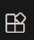
- Search Platform IO and install the Platform IO extension
- Trust Platform IO if a popup box appears.
- Click Reload Extensions after Platform IO installs.
- From the left-hand toolbar, click the Extensions icon: 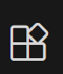
- Search for the Microsoft C/C++ Extension and install it if it’s not already installed. It’s Microsoft, so no trust needed.
- Search for the GitHub Copilot Chat extension and install it.
- The installed extensions should look like this when you’re done:
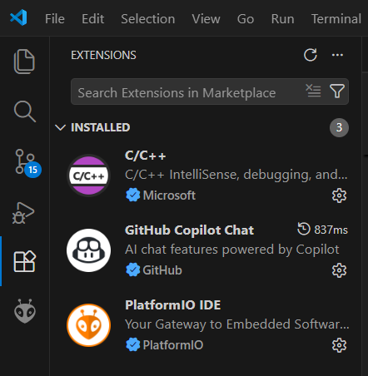

- Restart VS Code

- Click on the Platform IO Icon  to initialize the Platform IO core. It should look like this when it finishes:

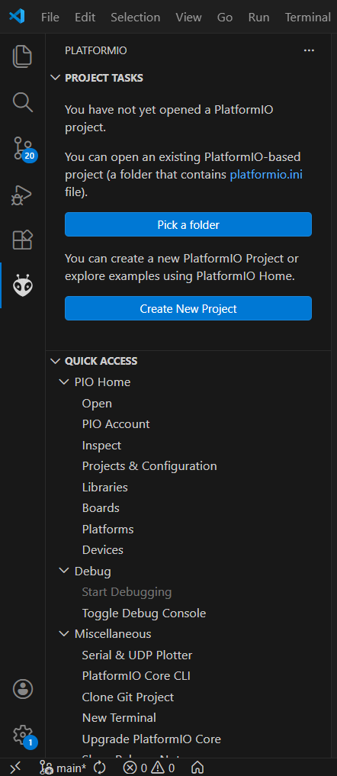

Cloning the Microcontroller Training Repository
- A repository is the collection of code and other files associated with a project. “Cloning the Microcontroller Training Repository” means literally copying the files in this location to our local hard drive.
- Create the folder C:\Users\CrazyUncleBurton\Documents\PlatformIO\Projects (replace “CrazyUncleBurton” with the userID that you logged in with). We have chosen this to be the location where we will clone the repository of lessons because that’s where Platform IO puts them by default.
- 3. Open a web browser and go to this location:
- https://github.com/CrazyUncleBurton/Microcontroller-Training

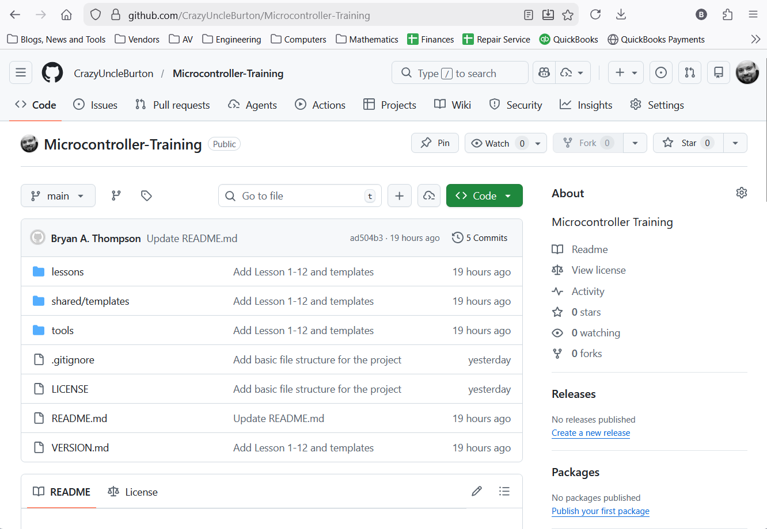

- Click the green Code button:
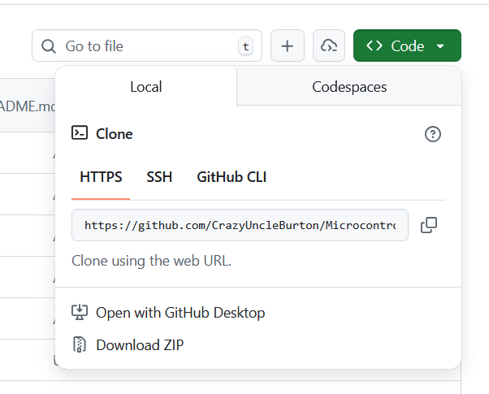

- Click Download Zip and remember the location where you download the file.
- Extract the contents of the Zip and place that project folder in this folder (create the parent folder if needed): C:\Users\CrazyUncleBurton\Documents\PlatformIO\Projects (replace “CrazyUncleBurton” with the userID that you logged in with).

- Go to the folder C:\Users\CrazyUncleBurton\Documents\PlatformIO\Projects (replace “CrazyUncleBurton” with the userID that you logged in with). It should look like this:

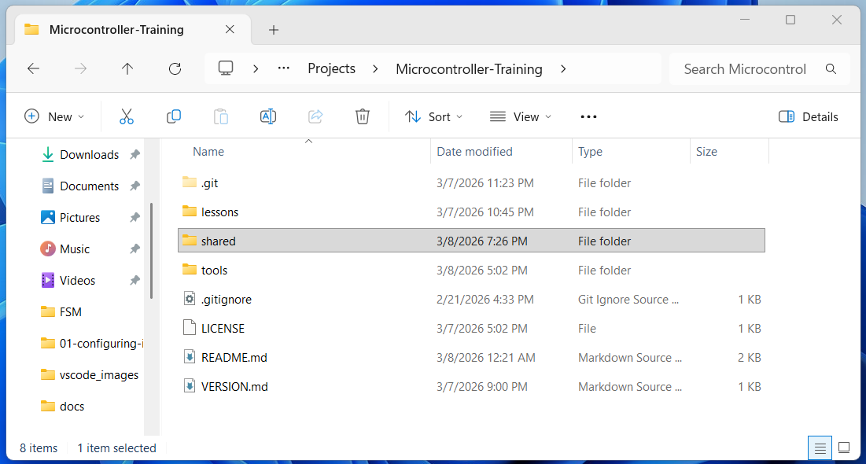

- The lessons – including this one – are located in the “lessons” folder:

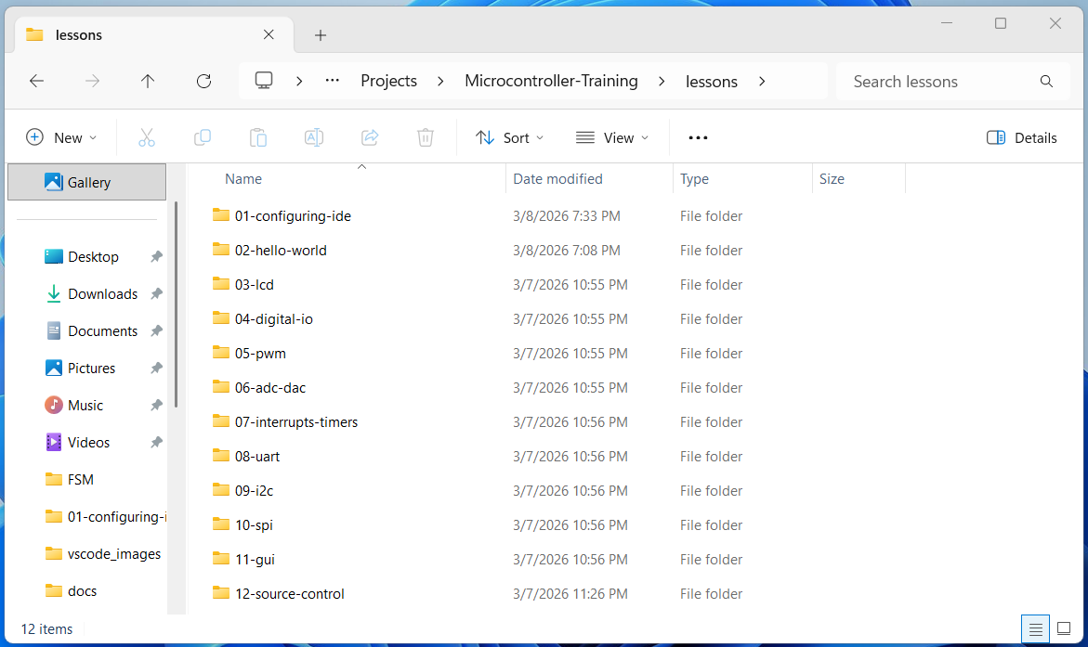

- Browse into the lesson 02-hello-world:

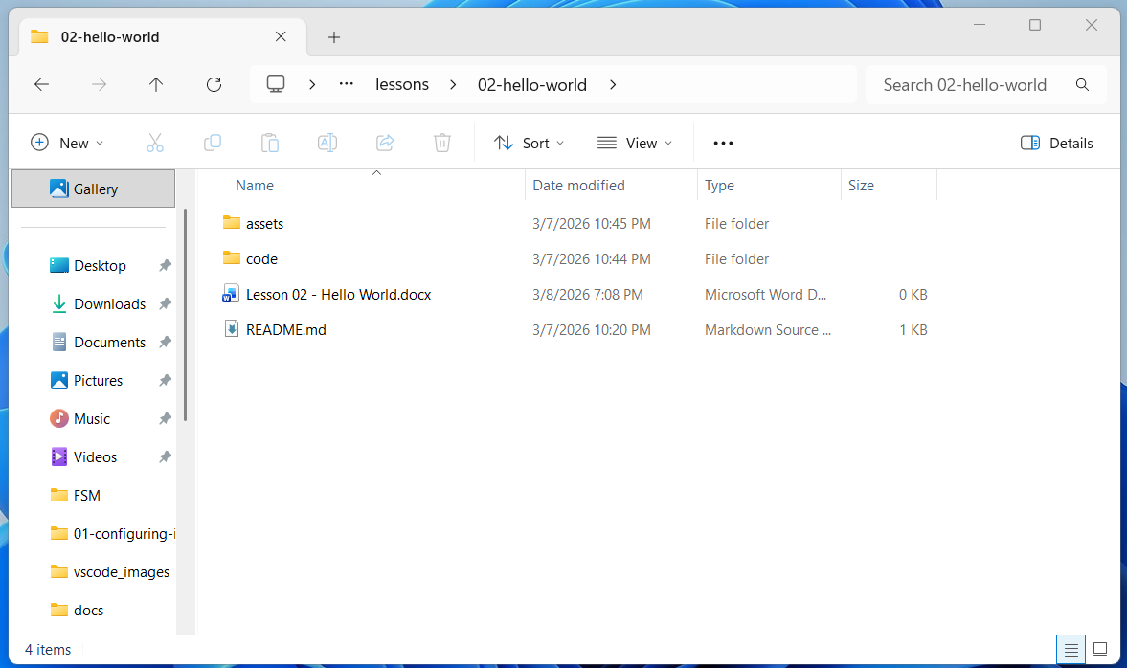

- Look at the file structure includes the Word Doc / PDF of the lesson at the top level. The README.md file contains lesson-specific notes. The assets folder contains any files we might need, like schematics, datasheets, etc. The “code” folder contains the code we will compile. There will likely be several programs for each lesson.
- This completes the software installation process. We will start the first program in Lesson 02 – Getting Started.

